AI Assistant Coding
Assignment-2.4
Name of Student : VEERAMALLA PRANEETH REDDY
Batch :42
Enrollment No. : 2303A52146

Task 1: Book Class Generation
Scenario:
You are building a simple library management module.
Task:
Use Cursor AI to generate a Python class Book with attributes title, author, and a summary() method.
Generated class
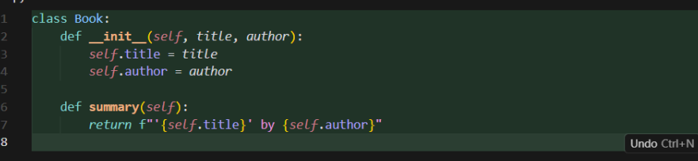
Student Commentary on Code Quality
The generated code is clean, minimal, and follows standard Python object-oriented programming conventions. The __init__ constructor correctly initializes instance attributes, and the summary() method encapsulates behavior related to the object, which aligns with good OOP design principles. The use of type hints improves readability and maintainability, making the code easier to understand and less error-prone for future extensions. Overall, the class is well-structured and suitable for a basic library management module.

Task 2: Sorting Dictionaries with AI
Scenario:
You need to sort user records by age.
Task:
Use Gemini and Cursor AI to generate code that sorts a list of dictionaries by a key.
Code 1 cursor ai :
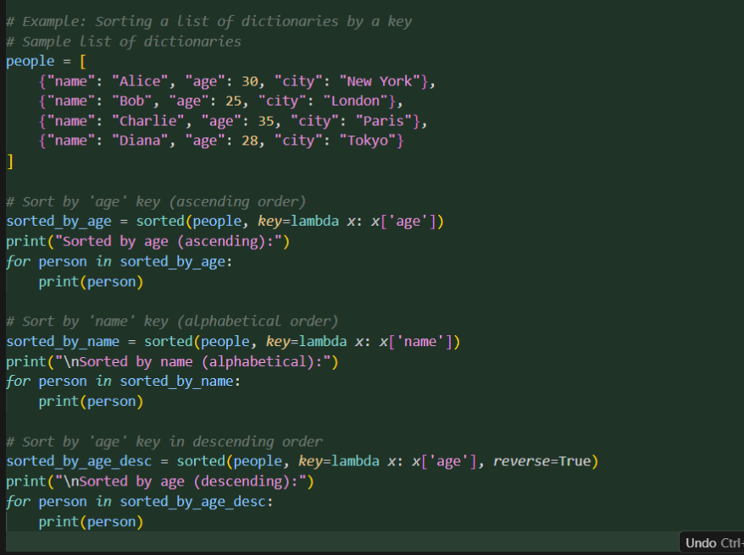
Code2 gemini :
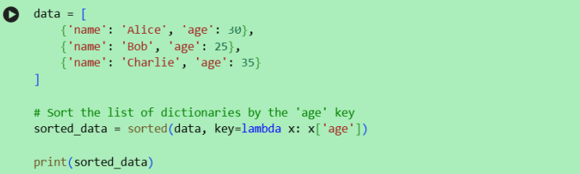
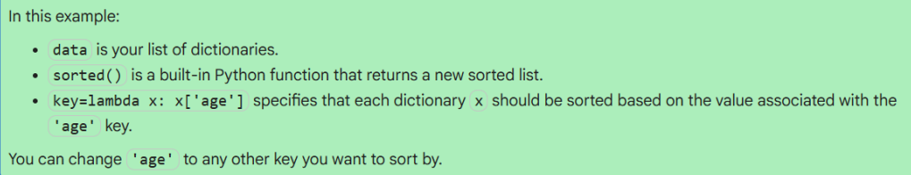
Output cursor 1 :
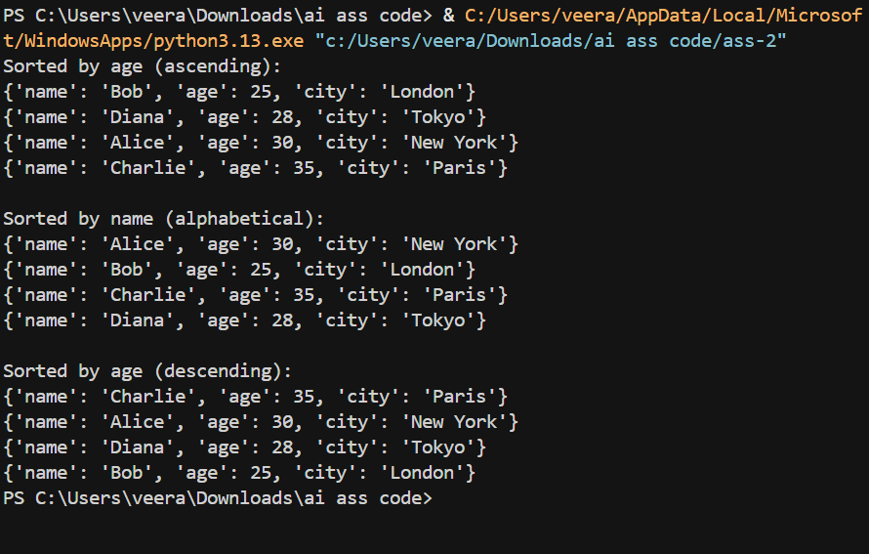
Output2 gemini:
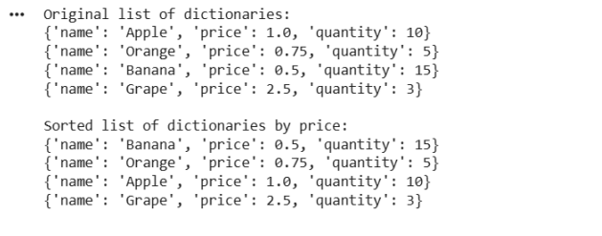
Comparison: Clarity and Performance
Clarity

• Gemini AIproduces a more concise and immediately readable solution. The intent (sorting by age) is explicit and requires minimal cognitive overhead.
• Cursor AI introduces an additional function, which slightly reduces immediate clarity but improves structure and reusability in larger codebases.
Performance
• Both implementations use Python’s built-in sorted() function with a lambda key, resulting in identical time complexity: O(n log n).
• There is no meaningful performance difference for typical workloads. Cursor AI’s use of dict.get() adds negligible overhead but provides safer handling of missing keys

Overall
• For quick scripts or interviews: Gemini AI’s output is preferable due to simplicity.
• For production or reusable modules: Cursor AI’s output is preferable due to better defensive coding and extensibility.
Task 3: Calculator Using Functions
Scenario:
You are reviewing a basic calculator module.
Task:
Ask Gemini to generate a calculator using functions and explain how it works
Code:
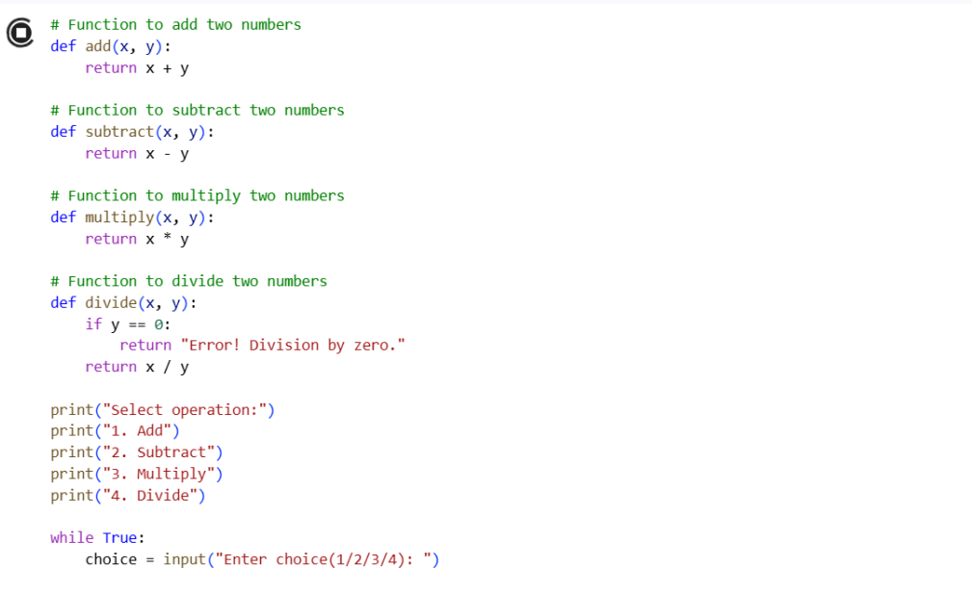
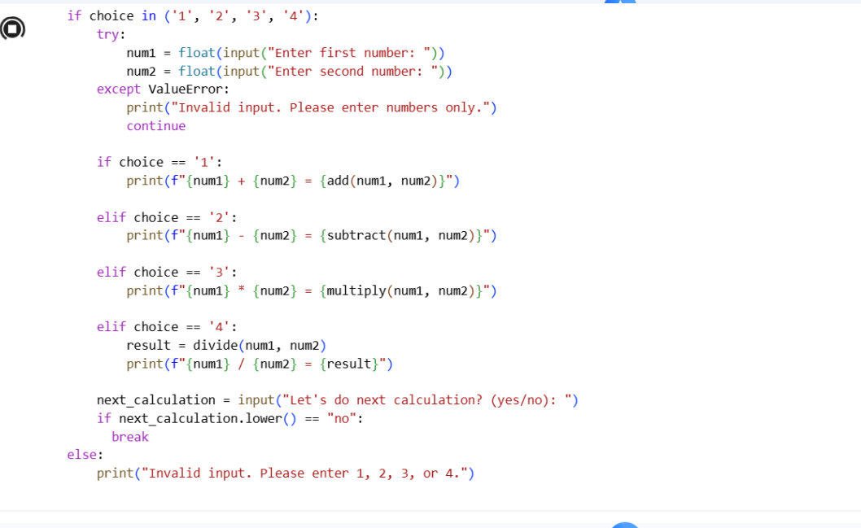

Gemini AI – Explanation of How It Works
This calculator is implemented using separate functions for each arithmetic operation, which improves modularity and readability.
• Each function (add, subtract, multiply, divide) accepts two parameters and returns the computed result.
• The divide() function includes a safety check to prevent division by zero, which demonstrates basic defensive programming.
• The main section of the code defines two variables (x and y) and calls each function, printing the results.
• This structure makes the calculator easy to test, maintain, and extend (for example, adding modulus or power functions later).
Overall, the logic is clear, beginner-friendly, and follows good procedural programming practices.
Screenshot
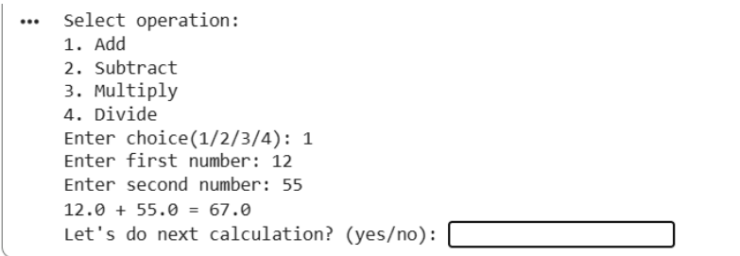
Task 4: Armstrong Number Optimization
Scenario:
An existing solution is inefficient.
Task:
Generate an Armstrong number program using Gemini, then improve it using Cursor AI.
Code of gemini :
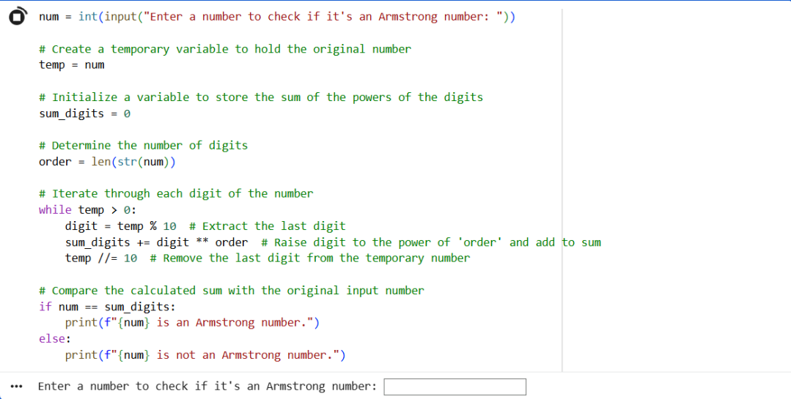

Code of cursor
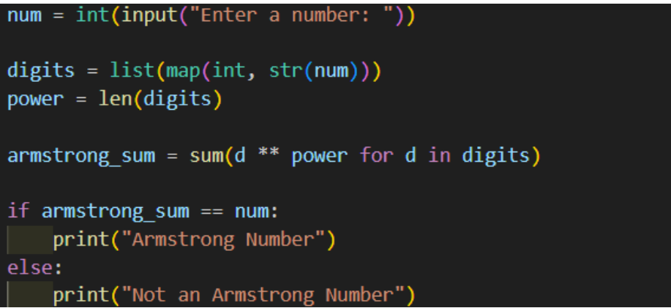

Summary of Improvements
- Reduced Complexity of Loops
o Gemini’s version uses two separate while loops and manual digit extraction.
o Cursor’s version converts the number to a string once and processes digits in a single expression.
- Improved Readability
o The optimized code is shorter and more expressive.
o Use of list comprehension and sum() clearly communicates intent.
- Better Maintainability
o Fewer variables and no manual loop control reduce the chance of logical errors.
o Easier to modify or extend for related numeric problems.
- Performance Consideration
While both are efficient for small numbers, the optimized version minimizes iterations and is preferable for cleaner, production-quality Python

